Exercise 1:

# Impute missing values (categorical variables)

train.Gender.fillna("Female",inplace=True)

train.Married.fillna("No",inplace=True)

Exercise 2:

# Impute missing values (numerical variables)

train.fillna(train.median(),inplace=True)

Exercise 1:

Exercise 2:

train.isnull().sum()

train.median()

Exercise 3:

#Split train data for cross validation

from sklearn.model_selection import train_test_split

x_train,x_cv,y_train,y_cv = train_test_split(X,y,test_size=0.3)

Exercise 4:

#Predict values using kNN

pred_test=kNN.predict(test)

#Write test results in csv file

predictions=pd.DataFrame(pred_test,columns=['predictions']).to_csv('knn_prediciton.csv')

np.unique(pred_test, return_counts=True)

Exercise 3:

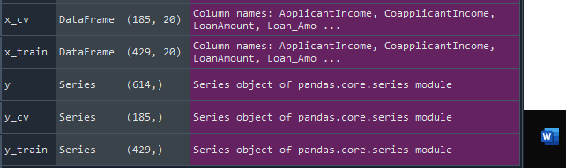

Exercise 4:

(array(['N', 'Y'], dtype=object), array([ 60, 307], dtype=int64))

Exercise 5:

Exercise 5:

the AUC-ROC score for Random Forest is 0.7466867469879518  
  
